
January 2026
WCC AGM
Thursday 12th February 2026 at 7.30 pm in Woodford Church Hall

The formal AGM meeting will include:
- A brief annual report
- Approval of the minutes of the last AGM
- Approval of the accounts for the last year
- Election of the management committee for the next year

The formal AGM will be followed by a brief update meeting, including
- Summer Fair
- Winter Fest
- Status of development proposals in and around Woodford
- Status of the draft Stockport Local Plan

There are vacancies on the management committee. We need new volunteers to help us to run the committee, encourage community participation and organise fun community events, including the Woodford Summer Fair and Woodford Winterfest.

If you would like to be involved, please make contact via the website.

Woodford Summer Fair
Held annually in June at the Woodford Community Centre.
The event this year will be held on Saturday 20th June. Details in a later edition of this newsletter.


Lots of fun for all the family, including activities for children, fairground, face painting, market stalls with local traders, local organisations, licensed bar, food, refreshments and live music. Free entry.

If you wish to become involved as a volunteer please contact Avril on woodfordshowcase@gmail.com
Woodford Winterfest
Held annually in December at the Woodford Community Centre

More fun for the family with Christmas market stalls, fairground rides, food, bar, tea and cakes, children’s dancing demonstrations, live music, carol singing, and Santa’s grotto.



If you wish to become involved as a volunteer or take a trading stand please contact Avril on woodfordshowcase@gmail.com

Proposed Development in and Around Woodford
To keep up to date please visit the Woodford Neighbourhood Forum website www.woodfordnf.co.uk
Here is a brief update:

Stockport Local Plan
It is a legal requirement for a Council to prepare a Local Plan for the next 15 years. Government planning guidelines inform the preparation process. The purpose is to plan for future housing, employment, and infrastructure needs, such as health, education, recreation, transport and green spaces, aiming to produce sustainable development which protects the environment, climate and nature.

Publication of the new draft Local Plan was subject to successive delays due to changes in central Government and successive changes in their planning guidelines and housing targets. The latest changes to the national planning guidance introduced a new concept of “grey belt” for Green Belt land that failed to meet a subset of three of the five functions of Green Belt. As a result, the Council needed to conduct a detailed revised assessment of land with Green Belt status in the borough. In addition, the Government revised the methodology for assessing housing need which resulted in an almost doubling of the target number of houses to be built in the borough to 31,790 homes by 2040.

The Council reported that previously developed land (brownfield sites) was available for 16,406 homes, leaving a shortfall to be built on grey belt and Green Belt sites.

The current draft plan would produce 25,371 new homes during the plan period, which is 80% of the target number.

The draft Local Plan also includes a Vision, Objectives, Strategic Policies and Development Control Policies, which aim to guide decisions on planning applications, as well as proposing sites for new development. The documents associated with the Plan can be found on this link.

The sites proposed for new development in Green Belt in Woodford amount to a total of 1,285 new dwellings on the following sites:

Woodford Garden Village Extension: 545 homes
Chester Road (Woodford): 550 homes
Jenny Lane: 190 homes

Just down the road in Bramhall:
Hall Moss Lane: 400 homes

Consultation on the draft Local Plan closed on 21st December 2025

Woodford Neighbourhood Forum submitted a response to the consultation, which you can find here.

Points raised included:
- Over development of Woodford
- Impact on local infrastructure, especially highways and hospital
- Loss of agricultural land and impact on heritage and economy
- Loss of wildlife habitats and corridors
- Loss of fields with natural vegetation which act as carbon sinks and flood defence
- Negative impact on landscape and rural character
- Cumulative impact due to other developments close by, including Handforth Garden Village (1,500 dwellings plus commercial premises)

The next steps will include publication of amendments to the draft plan by the Council, further consultation, followed by submission to Government for Examination in Public by a Government appointed planning inspector, who will assess whether the Plan complies with legal requirements and Government guidelines, including meeting the target number of new homes before it can be adopted. This is likely to be in 2027/2028 at the earliest.

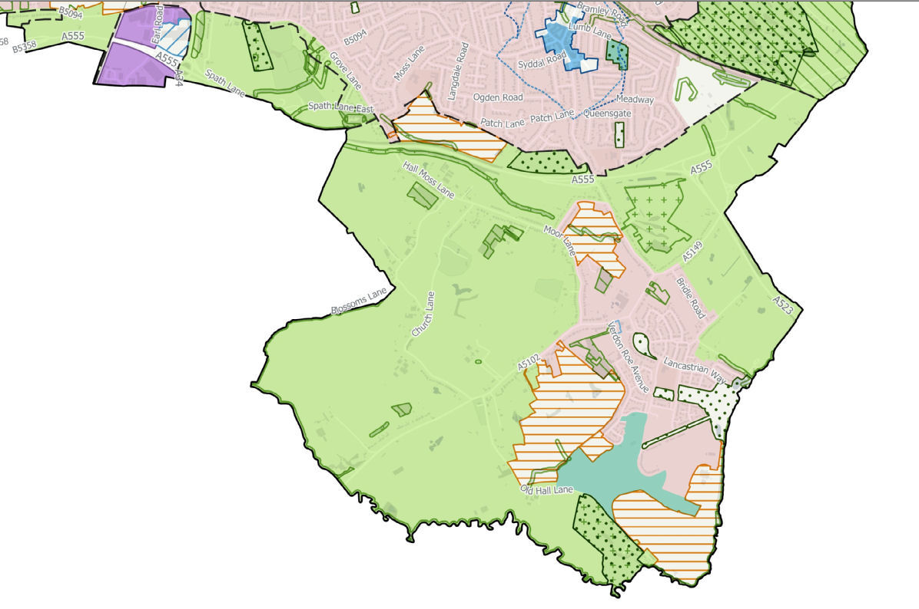
The sites currently in Green Belt proposed for development are marked with orange cross hatching.

Land South of Chester Road
Russell Homes submitted a planning application for “Woodford Garden Neighbourhood”, which involves development of 545 dwellings on Green Belt land between Chester Road, Old Hall Lane and Woodford Garden Village. The reference number for the planning application on the Council planning website is DC/096927. The Council consultation closed on 10th October.

The Woodford Neighbourhood Forum response to the planning application can be found here

The site is allocated in the draft Stockport Local Plan for 545 dwellings. The site being the subject of a planning application and an allocation in the Stockport Local Plan may be a complicating factor.

Land off Hall Moss Lane, Bramhall
Jones Homes submitted an outline planning application for the development of 250 new homes off Hall Moss Lane, Bramhall. The Council consultation period for this application was extended following a glitch in the council planning portal and closed on14th January.
Woodford Neighbourhood Forum submitted a response to the planning application which can be found here.
Local residents have formed an action group and their website is here.
The site is an allocated in the Stockport Local Plan for 400 dwellings. The site being the subject of a planning application and an allocation in the Stockport Local Plan may be a complicating factor.
Woodford Garden Village Extension, Chester Rd, Woodford
The developer, Redrow, lodged an appeal due to non-determination by the Council of their planning application within the deadline.

The Inquiry hearings will be held on 3rd, 4th, 5th, 6th and 10th February 2026 at Fred Perry House in Stockport. Members of the public may attend the Inquiry and, at the Inspector’s discretion, express their views. If you wish to participate in the Inquiry, please contact the Local Planning Authority (email: planningappeals@stockport.gov.uk ) and Programme Officer (email: yvonneparker@programmeofficers.co.uk ) quoting reference “Woodford Garden Village Extension - Inquiry Attendance” for details of how to do so.

The documents presented for the Inquiry can be found on this link: https://programmeofficers.co.uk/Gatley/InquiryDocumentsfinal.pdf

Woodford Action Group has been formed. You can find their website on the link.
Adlington New Town
News of this proposal arrived out of the blue one Sunday morning in September. It is one of twelve proposals for new towns put forward for consideration by a task force commissioned by the Government. The proposal for up to 20,000 dwellings covers 970 hectares of Green Belt land, 777 hectares of which is the Adlington Hall Estate, which was purchased by Belport Ltd in 2023. It stretches from Woodford Garden Village towards Poynton, Prestbury and Bollington and includes farmland with 15 working farms and environmentally sensitive areas. There has been widespread objection from members of numerous surrounding communities, including our own Cllr Peter Crossen and MP, Tom Morrison. Cheshire East Council voted unanimously against the proposal in December 2025 and the MP for Macclesfield, Tim Roca, spoke about the proposal in the House of Commons on 15th January 2026. You can read the transcript of his speech in Hansard on this link.
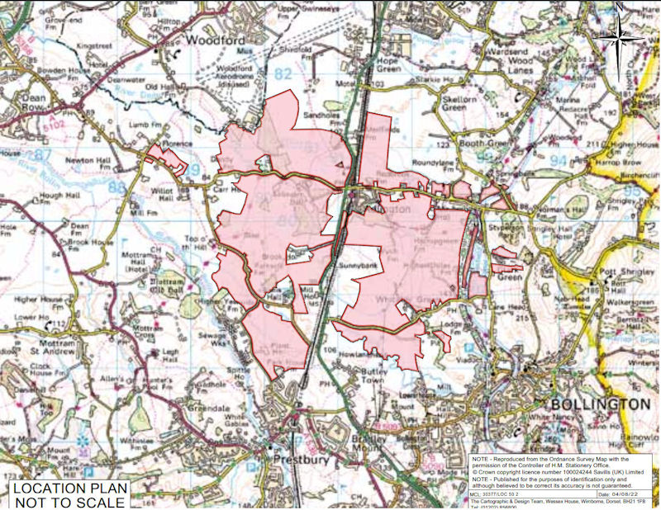
The area shaded in pink is the Adlington Estate
Woodford Community Organisations
We realise that the acronyms and roles of three of our community organisations can be confusing, especially to new residents. We hope the diagram and text below are helpful.

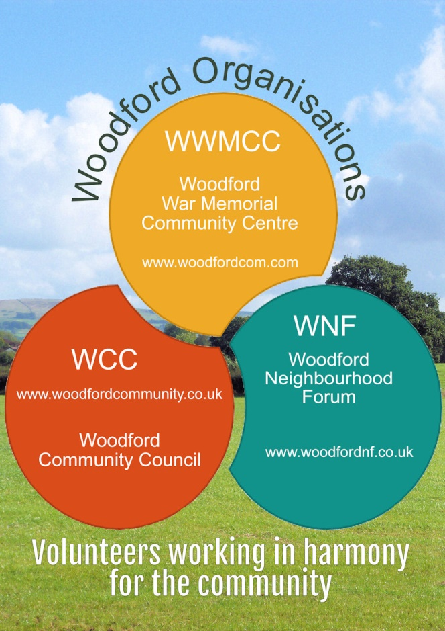

The Woodford Community Council (WCC) was established in 1974 when Woodford became part of the newly-formed Stockport Metropolitan Borough. All Woodford residents are entitled to attend and vote at the AGM and stand for election to the committee. Its purpose is to promote the interests of the residents of Woodford by addressing issues that affect the community and liaising with Stockport Council and other relevant bodies. It is funded by sponsorship and donations. WCC website

Woodford War Memorial Community Centre (WWMCC) is a registered charity and members of the Management Committee are its Trustees. All Woodford residents aged 18 years or over are automatically members. It is home to the Woodford Players and the Woodford Women’s Institute. Two halls and a large field available to hire for a variety of functions, including weddings, celebrations, children’s parties, craft events and dog shows. WWMCC website

Woodford Neighbourhood Forum (WNF) is a legally designated organisation established in 2013 to give the local community more opportunity to influence development proposals in the Neighbourhood Area. The Neighbourhood Area is the whole of Woodford, except Woodford Garden Village, which was excluded by Stockport Council at the request of Harrow Estates. The Management Committee prepared the Woodford Neighbourhood Plan, which was approved by residents at referendum and adopted in 2019. Now all planning applications in the Neighbourhood Area are assessed against the Neighbourhood Plan. For local development updates please visit the WNF website. WNF responses to planning applications are listed in a table here. This link provides an update on Development Proposals.

SPONSORS

Situated on the old AVRO airfield in a conversion of the old Fire Station donated by BAE Systems. `Opening times vary depending on the season and are available on the museum website.
More details on the Avro Heritage Museum website https://www.avroheritagemuseum.co.uk/
SIGN UP FOR THE NEWSLETTER
It is vitally important to all the communities surrounding Woodford that our views carry weight and that we can react promptly to changing events. For this, we need as many as possible to be signed up for the community newsletter. If a friend or an organization has forwarded this newsletter to you, please ensure that you continue to receive copies of all future newsflashes and newsletters by subscribing here.
If you no longer wish to receive the newsletter and newsflashes you can unsubscribe below.
Note: we respect your privacy and any personal information or data collected from the online forms will be dealt with in accordance with our privacy policy.

Copyright © 2019 Woodford Community Council, All rights reserved.
Our mailing address is:
Woodford Community Council
c/o Woodford Community Centre, Chester Road
Woodford
Stockport, Cheshire SK7 1PS

United Kingdom
Add us to your address book
unsubscribe from this list update subscription preferences

